Homework #29: Solution
A
B
C
p₀
¼p₀
V₀
3V₀
p
V
$$V_{0}=0.1{ m}^{3} \\ p_{0}=60kPa \\ \begin{matrix}pV & =nR \\ \text{a)} T_{i} & =\frac{p_{0}V_{0}}{nR}=\frac{60×{10}^{3} Pa⋅0.1{ m}^{3}}{2.5 mol⋅8.3 J{ mol}^{-1}{ K}^{-1}}\end{matrix}$$
$$\begin{matrix} & T_{i}=289 K \\ & T_{f}=\frac{\frac{1}{4}p_{0}3V_{0}}{hR}=\frac{3}{4}T_{i}=216 K\end{matrix}$$
b) $W_{A}=p_{0}\left(3V_{0}-V_{0}\right)=2p_{0}V_{0}=12.0 kJ$
$$\begin{matrix}W_{B} & =\frac{1}{2}\left(3V_{0}-V_{0}\right)\left(p_{0}-\frac{1}{4}p_{0}\right)+\frac{1}{4}p_{0}\left(3V_{0}-V_{0}\right) \\ & =\frac{1}{2}2V_{0}⋅\frac{3}{4}p_{0}+\frac{1}{4}p_{0}⋅2V_{0} \\ & =\frac{3}{4}p_{0}V_{0}+\frac{1}{2}p_{0}V_{0}=\frac{5}{4}p_{0}V_{0}=7.5 kJ \\ W_{C} & =\frac{1}{4}p_{0}\left(3V_{0}-V_{0}\right)=\frac{1}{2}p_{0}V_{0}=3.0 kJ\end{matrix}$$
c) $ΔU=Q-W=nc_{v}ΔT$ same for all 3 processes
$ΔU=n\frac{3}{2}R\left(T_{f}-T_{i}\right)=n\frac{3}{2}R\left(\frac{\frac{3}{4}p_{0}V_{0}}{nR}-\frac{p_{0}V_{0}}{nR}\right)=-\frac{3}{8}p_{0}V_{0}=-2.25 kJ$ negative ($T_{f}<T_{i})$
d) $Q_{A}=ΔU+W_{A}=9.75 kJ$
$$Q_{B}=ΔU+W_{B}=5.25 kJ \\ Q_{C}=ΔU+W_{C}=0.75 kJ$$
$$\begin{matrix} & \text{Alter}\text{native:} \\ & Q_{A}=nC_{p}\left(\frac{3p_{0}V_{0}}{nR}-\frac{p_{0}V_{0}}{nR}\right)+nC_{v}\left(\frac{3/4p_{0}V_{0}}{nR}-\frac{3p_{0}V_{0}}{nR}\right) \\ & =n\frac{5}{2}R\left(\frac{2p_{0}V_{0}}{nR}\right)+n\frac{3}{2}R\left(\frac{-9p_{0}V_{0}}{4nR}\right) \\ & =5p_{0}V_{0}-\frac{27}{8}r_{0}V_{0}=\frac{13}{8}p_{0}V_{0}=9.75kJ\end{matrix}$$
$$\begin{matrix}Q_{C} & =nC_{V}\left(\frac{1/4p_{0}V_{0}-p_{0}V_{0}}{nR}\right)+nC_{p}\left(\frac{3/4p_{0}V_{0}-1/4p_{0}V_{0}}{nR}\right) \\ & =n\frac{3}{2}R\frac{\left(-3/4p_{0}V_{0}\right)}{nR}+n\frac{5}{2}R\frac{1/2p_{0}V_{0}}{nR}=-\frac{9}{8}p_{0}V_{0}+\frac{5}{4}p_{0}V_{0}=\frac{p_{0}V_{0}}{8} \\ & =0.75 kJ\end{matrix}$$

2. Stirling Cycle
a
P
V
V_{a}
3V_{a}
T_{H}
T_{C}
b
c
d
$$a→b:ΔU_{ab}=0 \\ ΔU=Q-W=0$$
$$\begin{matrix}Q_{ab} & =W_{ab}=\int_{a}^{b}{ } pdV=\int{ }\frac{nRT}{V}dV \\ & =nRT_{H}\int_{a}^{b}{ } \frac{dV}{V}=nRT_{H}ln⁡\frac{3V_{a}}{V_{a}} \\ Q_{ab} & =W_{ab}=nRT_{H}ln⁡3\end{matrix}$$
$$b→C$$
$$W_{bc}=0$$
$$ΔU_{bc}=Q_{bc}=nC_{v}ΔT=n\frac{5}{2}R\left(T_{C}-T_{H}\right)$$
$$c→d$$
$$ΔU_{cd}=0$$
$$\begin{matrix}Q_{cd} & =W_{cd}=\int_{c}^{d}{ } pdV=\int{ }\frac{nRT}{V}dV \\ & =nRT_{C}\int_{c}^{d}{ } \frac{dV}{V}=nRT_{C}ln⁡\frac{V_{a}}{{3V}_{a}} \\ Q_{ab} & =W_{ab}=-nRT_{C}ln⁡3\end{matrix}$$
$$d→a$$
$$W_{da}=0$$
$$ΔU_{da}=Q_{da}=nC_{v}ΔT=\frac{5}{2}R\left(T_{H}-T_{c}\right)$$
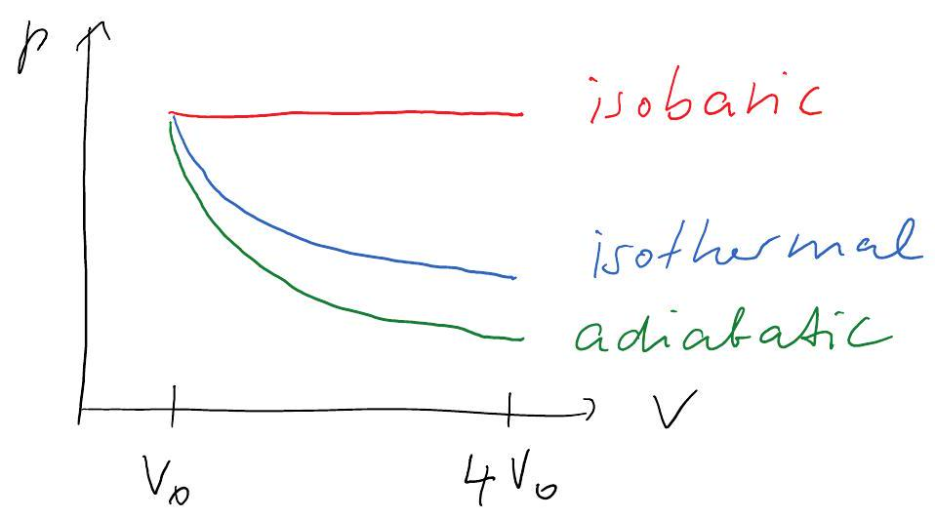
a) Work=area under the p-V-curve greatest for isobaric
b) smallest for adiabatic
c) $ΔU=$ const for isothermal
$⇒ΔU>0$ for isobaric, ends at higher isothermal
d) $ΔU<0$ for adiabtatic $Δu=Q-W=-W$
e) $Q=0$ for adiabatic
$$ΔU=Q-WΔU>0$$ for isobaric, $W$ is max, $Q>W$ $→$ largest $Q$for isobaric

